Action RPG in VR Template  
Games User Research Report

# Report’s Purpose/Aim

With many Action RPGs like Asgard’s Wrath 2 (Reviews: 4.2/5 Meta, 10/10 IGN, and 86% Metacritic) and Skyrim VR (Reviews: 7/10 Steam, 6.8/10 IGN, and 77% Metacritic) taking over the virtual reality marketplace via SteamVR and Meta platforms. From the possibility of RPGs taking over in virtual reality, I have decided to look further into that genre by studying the user experience via the prototype build of an Action RPG template. In this case, it will provide more insights from user experiences and understand what they want to achieve from games following that genre. It will look into the positives and negatives of the template, along with additional suggestions that future developers may like to add and modify when choosing this template. That way in the future, the concept of this template can be improved to support more features and better suit the developer’s and gamer’s needs.

# Study Methodology/Design

This study will allow participants to run a three-part simulation of the Action RPG template (movement, weapon handling, and battle system) built in Unity with XR support. Meta Quest 2 (with Touch controllers) will be the simulation platform/console.

Before participating, they will sign a ‘Participant Information and Consent Form’ to indicate that participants will be invited to sign the consent form, followed by an evaluation of the template build, before then completing the post-evaluation forms such as surveys and questionnaires. Risks are identified in the consent form such as motion sickness, and danger to obstructions. Lastly, if they consent, they are requested to enter demographic information such as names, age, and the number of years of experience in gaming and game development.

After the consent form is completed, participants will be asked to wear the Meta Quest headset and grab the Touch controllers, in which case they will be given time to adjust to the virtual surroundings before beginning the simulation. All instructions are made within the simulation, so they do not have to be relayed verbally.

The first part of the simulation experiments with movement which focuses on the joystick on the left and right controllers, as well as the participant’s head perspective. Once they are done, they would proceed to the spot where the sword lies on the stand.

The second part of the simulation experiments with weapon handling, using the main weapon that the player possesses: the sword. They can use the sword to swing and attack damageable objects, by first allowing the participant to strike against the test dummy as many times as they want, before requiring themselves to destroy a breakable wall and proceed.

The third and final part of the simulation experiments with a battle system, making the participant complete a mini-level involving numerous enemies through a linear field. This makes use of the sword and the health system given to the player and the enemy.

After the simulation is complete, participants will be requested to complete a survey and a questionnaire before the evaluation is completed. The survey involves a list of qualitative questions, three each on every mechanic, which prompts them to answer with detailed responses and criticism. The questionnaire involves a list of quantitative questions that support the PENS (Player Experience of Needs Satisfaction) subscale scoring (7-point Likert scale). Essentially it focuses on Competence, Presence/Immersion, and Intuitive Controls in the questionnaire, and all of the questions are randomized in order.

# Participants

Eight participants evaluated the template concept and provided demographic information to analyse. According to the data collation on the experience in gaming and game development, all participants have substantial years of gaming (+8 years), and decent amounts of years in game development. In short, this evaluation was more focused on gamers rather than game developers.

Forms response chart. Question title: How many years of experience have you had with gaming?
. Number of responses: 8 responses.

Figure : Bar graph showing years of experience in gaming.

Forms response chart. Question title: How many years of experience have you had with game development?
. Number of responses: 8 responses.

Figure : Bar graph showing years of experience in game development.

# Results and Analysis

The positives and negatives will mainly focus on the questionnaire through PENS scoring collation, while the suggestions will focus on some of the most interesting design choices to add over the base template from surveys. There will be some cases of mixing between due to some feedback.

## Positives

According to the PENS Intuitive Controls, participants gave high praises for the simplicity and easiness of controlling. The use of movement and weapon handling executed well in teaching the player how to handle the controls from start to end. The total score in Intuitive Controls ended with 6.67 out of 7.

Figure : Table showing data of PENS Intuitive Controls with total average.

In terms of Competence, participants picked up the simulation’s instructions and difficulty easily. The third part of the simulation was slightly harder to complete than the first two, but eventually ended up completing the simulation in optimal time. The total score in Competence ended with 5.83 out of 7.

Figure : Table showing data of PENS Competence with total average.

## Negatives/Criticism

In the base template, it was clear that it lacked any story elements to the simulation as it only focused on Action RPG mechanics. Hence, it did not support any story elements in the template and made it feel limited to purely actions rather than having at least some storytelling. By looking at the bar graphs below, they struggled to provide immersive feelings to the participants due to the lack of story and design.

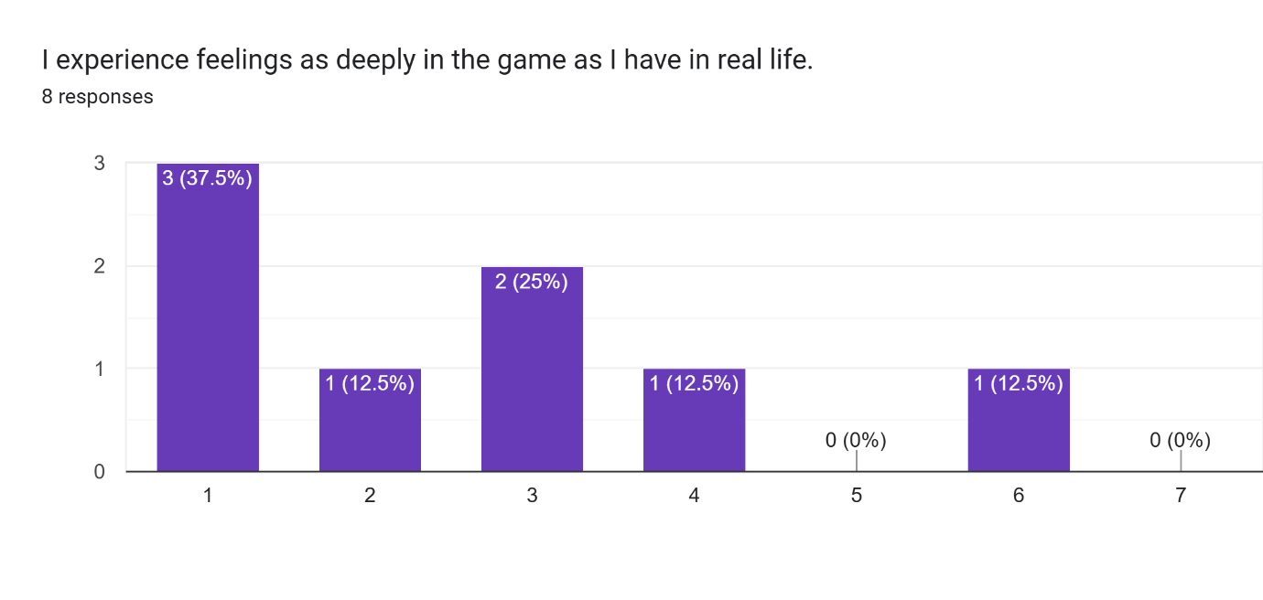

Figure : Bar graph showing the 7-point score in experiencing feelings in VR compared to real life.

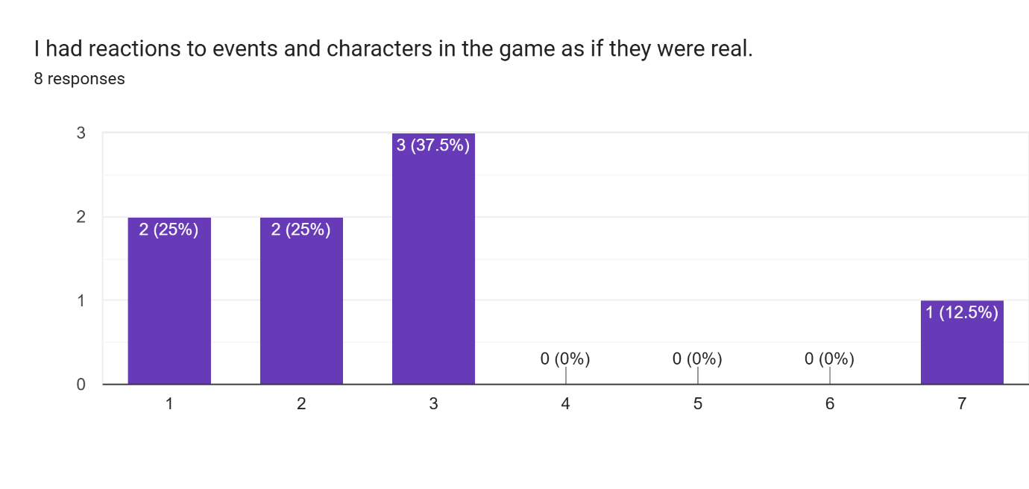

Figure : Bar graph showing the 7-point score in reacting to VR events and characters as if they were real.

In this case, it negatively impacted the Presence/Immersion greatly. The total score in Presence/Immersion ended with 3.79 out of 7.

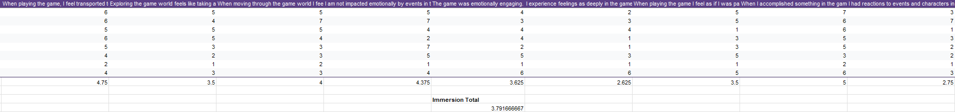

Figure : Table showing data of PENS Presence/Immersion with total average.

Lastly, there was a lack of accessibility and safety for participants. While the risks of motion sickness were mentioned, they could have been reduced. The choices to make smooth movements and turns contributed greatly to motion sickness. Additionally, there also should have been support for left-handed participants, as I had a participant go through the whole simulation while they were left-handed, which unfortunately forced them to fight with the sword in their right hand.

## Suggestions on Modifications and Additions

In the survey, the study asked participants this question:

*“If you were a developer and you were given access to making improvements in the battle system, what changes or additions would you add?”*

This is essentially allowing participants to provide their thoughts on how they would improve the template and make additions to their versions. These are the ideas they suggested:

* More enemy behaviour and varieties. For example, having unique attack animations which allow the player to dodge.
* More dynamic on sword attacking such as knockback. For example, if they were to swing the sword fast enough against an object, more damage would be dealt and it would knock back the enemy further.
* Changing the sword cooldown to enemy recovery cooldown instead, meaning that they would have to wait for the enemy to recover, allowing players to still hit other enemies while they wait.

Looking back on the points, they seem to add more complexities in various detections and systems from the template. The expectations from participants and users are fairly high when it comes to creating features for RPGs and VR, mainly because having varieties will make the concept more entertaining.

# Conclusion/Takeaway

After researching the user experience of an Action RPG concept, it is clear that gamers and developers seek to create highly demanding and unique features to capture the target audience and make VR games successful. Unfortunately at this conceptual level, it has yet to be optimal for VR immersion and will take more time and resources to design and implement a better game. The template provided should at least help and influence future development over Action RPGs to thrive in the VR marketplace and create better RPGs for gamers to enjoy.